

Tunku Abdul Rahman University College

RTOS for Embedded Systems

***Task Switching***

|  |  |  |
| --- | --- | --- |
| **Name:** | Wong Jang Sing |  |
|  |  |  |
| **Reg. No:** | 15 WAR 09371 |  |
|  |  |  |
| **Programme:** | RMB 3 |  |
|  |  |  |
| **Date:** | 14 Aug 2016 |  |
|  |  |  |
| **Tutor:** | Dr. Poh Tze Ven |  |
|  |  |  |
|  |  |  |

**TABLE OF CONTENTS**

**Contents Page Number**

CHAPTER I: INTRODUCTION 4

1.1 Objective: 4

1.2 Brief Description: 4

CHAPTER II: METHODOLOGY 6

CHAPTER III: RESULT & DISCUSSION 10

**LIST OF FIGURE**

Figure 1 poping and pushing of the stack. 5

Figure 2 Tcb structure. 6

Figure 3 TCB initialization. 6

Figure 4 TCB representation. 7

Figure 5 Linked List for the TCB elements. 7

Figure 6 assembly function for pushRegs. 8

Figure 7 changing of SP. 9

Figure 8 ISR program code (Scheduler). 9

Figure 9 assembly function for updateSp and currentSp. 10

# CHAPTER I: INTRODUCTION

1.1 Objective:

Program has been written using $μVision$ v5.15 in both assembly and C language to implement a scheduler that enable the program to perform task switching. The result will be observed at the debugger of the $μVision$.

1.2 Brief Description:

In most of the system today, they are using preemptive multitasking rather than Cooperative multitasking. Which the preemptive multitasking includes a scheduler to tell the system when to perform which task. A scheduler usually represented by an Interrupt Service Routine (ISR). When the ISR scheduler timer expired, task switch will occur.

In this experiment, the scheduler will be designed by C and Assembly to perform task switching. The reason Assembly needed to be used is because in order to perform task switching, the internal register such as File Register (R1-R12), Stack Pointer (SP), Link Register (LR), Program Counter (PC) and Program Status Register (xPSR) have to be taken into the account which these registers are not visible by C program code.

The file register are simply a registers that store values. The SP is a pointer that is pointing to the top element of the stack. It usually operates with the command push and pop. The command push means to store the particular element in to the top of the stack and the address of the stack pointer will decrease by 4 if the element is size of 4 byte since each address only can store 1 byte size of element. While for pop, it is to take out the value from the top of the stack and the address of the stack pointer increase by 4. The illustration for pushing and poping of the stack is as shown below.

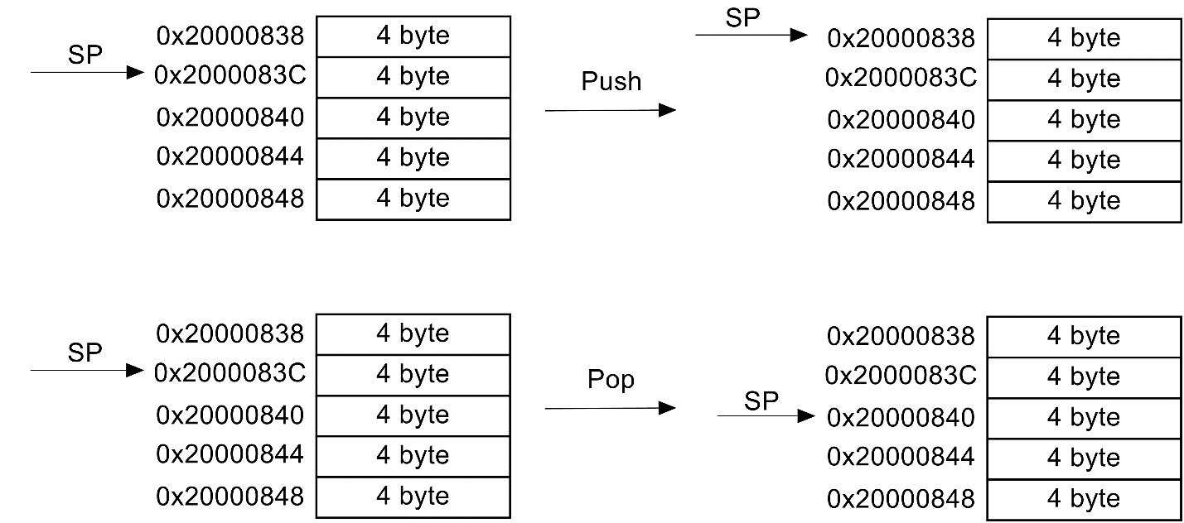

Figure 1 poping and pushing of the stack.

The LR is a register to store the address of the PC before entering the calling function and the PC is to store the address of the next instruction to be execute. The implementation of the scheduler will be discussed at the following chapters.

# CHAPTER II: METHODOLOGY

The element of each of the task has been represented by a Task Control Block (TCB). The structure created for the TCB is as shown below.

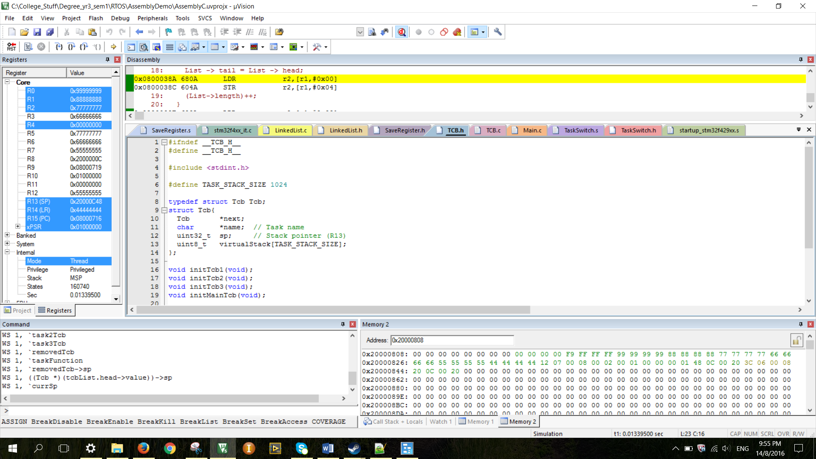

Figure 2 Tcb structure.

From the structure above, the ‘name’ is to represent the name of the task. The ‘sp’ is to store the address of the stack pointer (32 bit address). The ‘virtualStack[]’ is the array of the virtual stack with a fixed size of ‘TASK_STACK_SIZE’ which is defined to be 1024. Note that each of the element in the array is 1 byte which is mentioned in previous section.

The initialization of the TCB and the block diagram representing the TCB is as shown below.

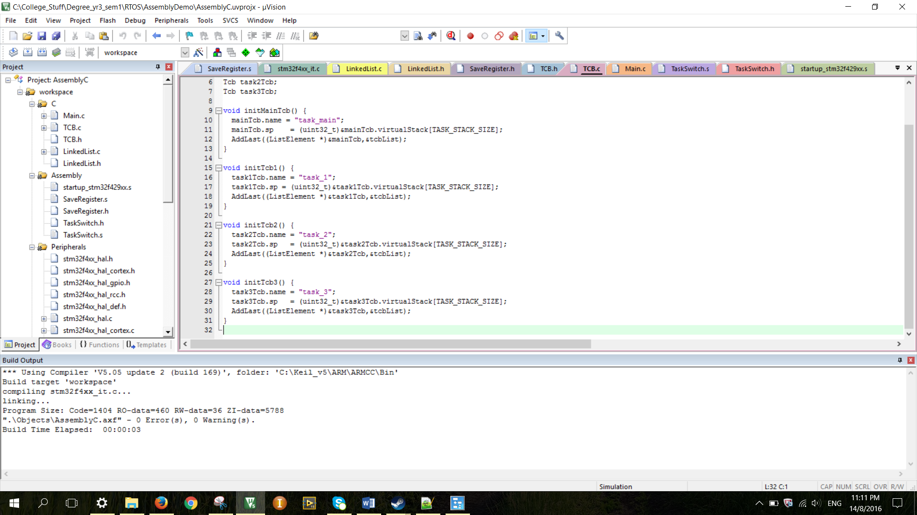

Figure 3 TCB initialization.

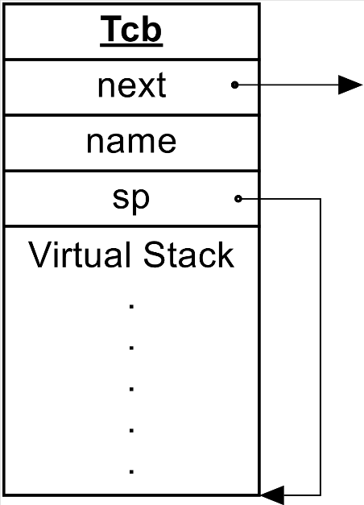

Figure 4 TCB representation.

From both of the figure above, each task has been given a name and the sp has initialized to be storing the highest address of the virtual stack which means by the virtual stack currently it is empty. Note that although the sp is a integer that store address but it is literally acting like a pointer that pointing to the highest address of the virtual stack.

Each of the TCB element has been linked together by the linked list, the diagram below represent the TCB linked list is as shown below.

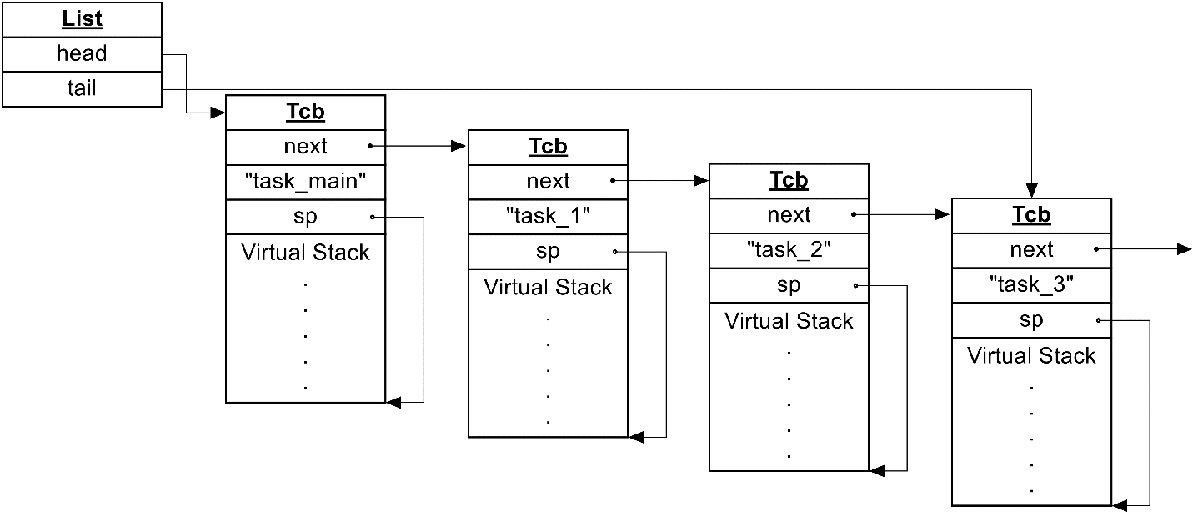

Figure 5 Linked List for the TCB elements.

From the figure above, all the virtual stack are still empty. The initialization of the virtual stack was performed by the function pushRegs( ). This function is written in assembly. The assembly function is as shown below.

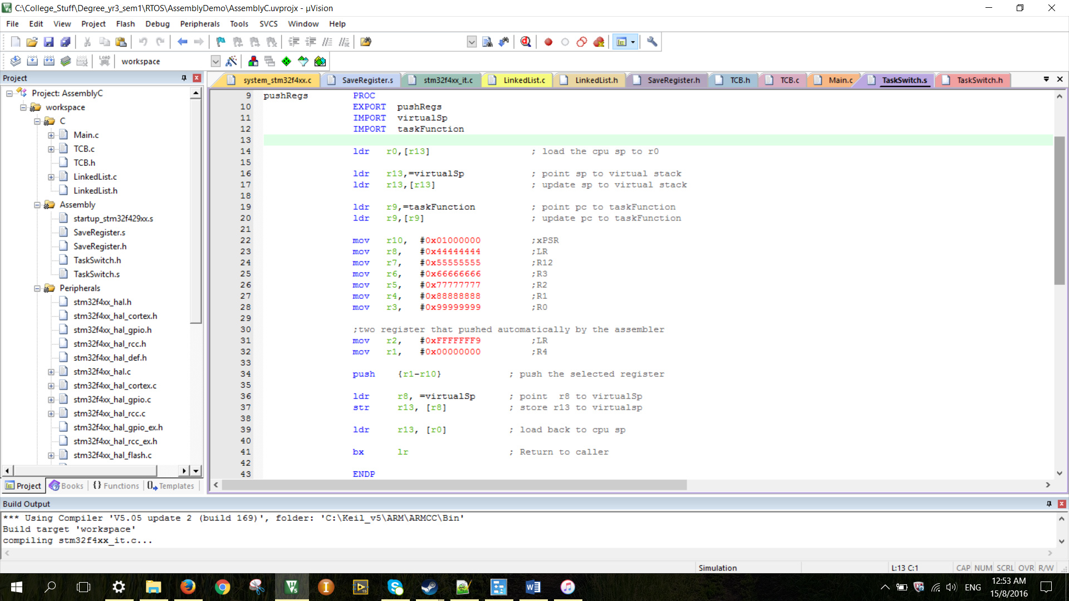

Figure 6 assembly function for pushRegs.

This function passed in two variable in C which are the ‘virtualSp’ and ‘taskFunction’.The virtualSp is to produce virtual stack pointer address and store the address of the SP and pass it out to C function. While for the taskFunction is to import in the address of the specific task. For the value of the registers are following the sequence of register being pushed when interrupt occur. When going out from this function, the virtualSp will give the SP address after the pushing. The changing of the sp is represented by the program code below.

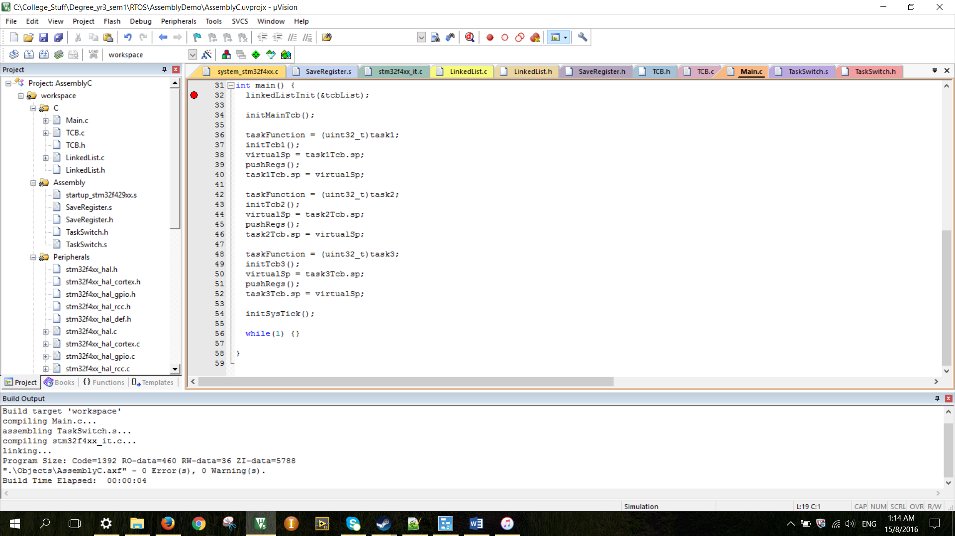

Figure 7 changing of SP.

After all the initialization has been done, the interrupt has been enabled and the program will get stuck in the infinite while loop until the timer expired. When the timer expired, the program will go into the ISR which is also known as a scheduler. The program code for the scheduler is as shown below.

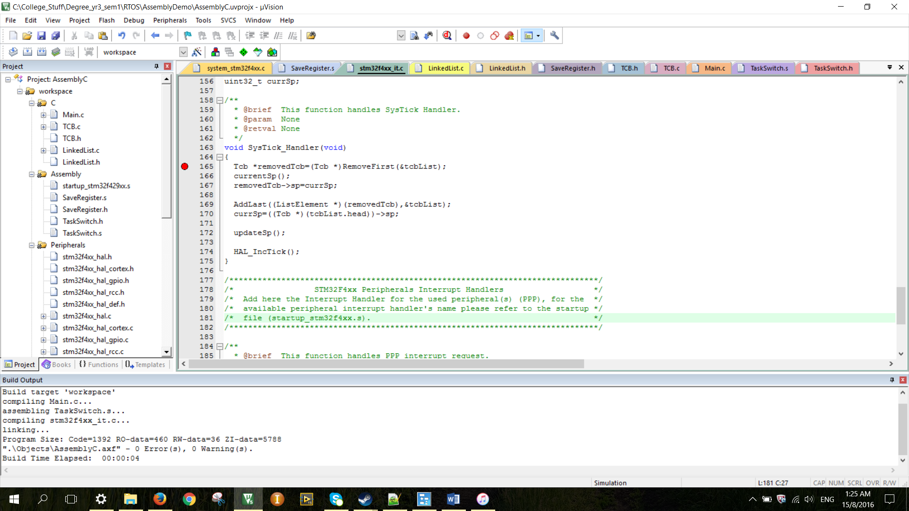

Figure 8 ISR program code (Scheduler).

The moment the program enter the ISR, there are some of the register has been pushed automatically. Which are R1, R2, R3, R12, LR, PC and xPSR. The SP of the first element in the linked list has to be updated because there are register pushed. The new SP value has been obtained by the assembly function currentSp( ). It will pass in the currSP and change the value to the current SP address.

After the sp of the removedTcb been update, the removed element has been thrown to the tail of the linked list. And now the SP has been changed to the SP of the head element by using the assembly function updateSp( ) which is the updated currSp. Since now the SP is pointing to the virtual stack of the task1 TCB, so the pop out value when leaving the ISR will be the register respect to the task 1. The PC value of the task 1 is the address of the function ‘void task1( )’. Thus, the next instruction after the ISR will be at the ‘void task1( )’. The process is iterative as long as it enter the ISR. ISR will do the task switching for the mainTask, Task1, Task2 and Task3. The program code for function updateSp( ) and currentSp( ) is as shown below.

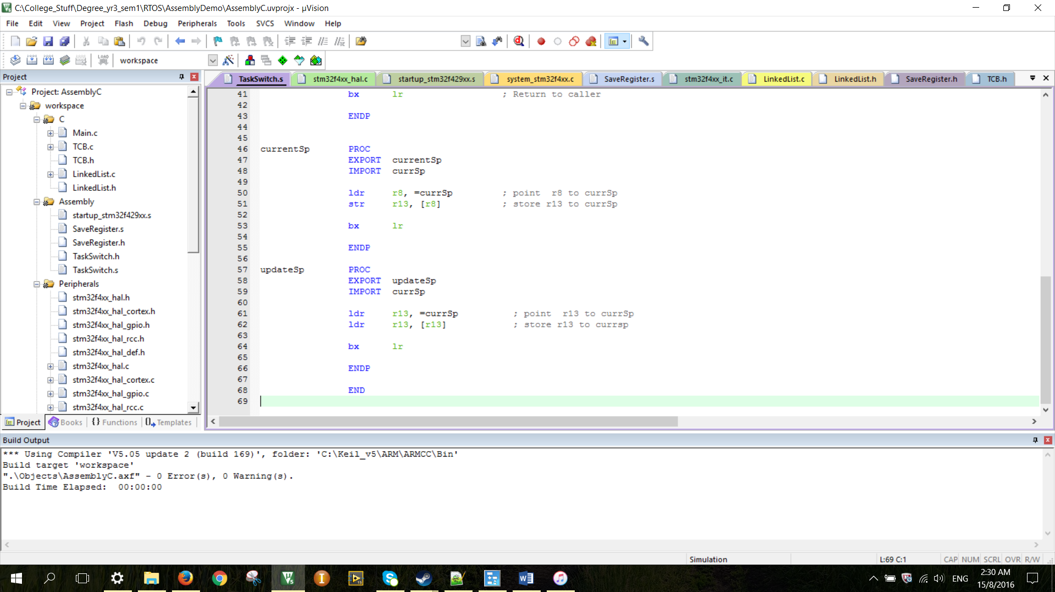

Figure 9 assembly function for updateSp and currentSp.

# CHAPTER III: RESULT & DISCUSSION

The result for the initialization of each of the TCB is as shown below.

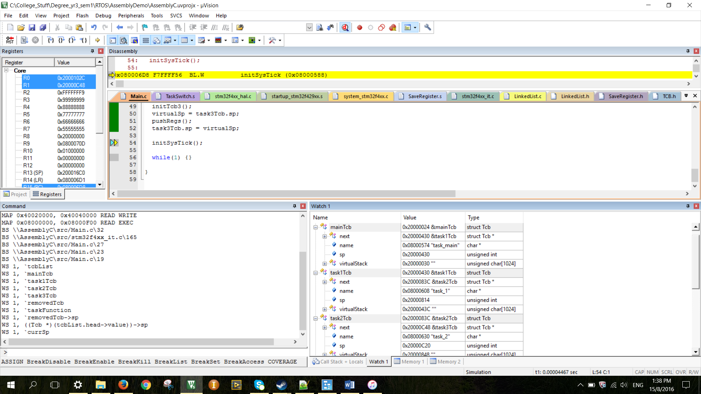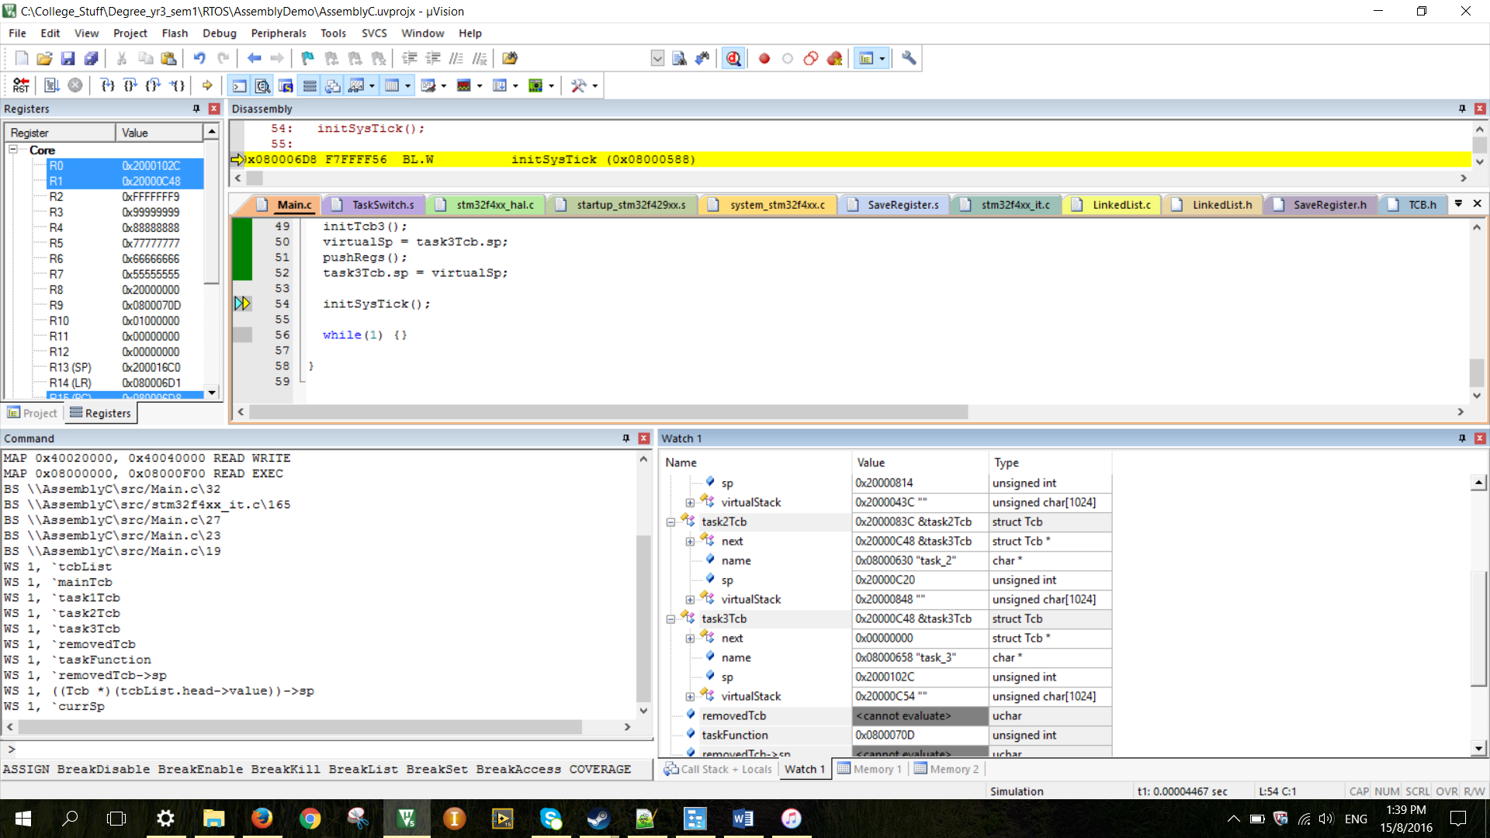

Figure 10 result of the initialization of TCB.

From the result above shows that the address of SP is 0x400 further away from the initial address of the virtual stack which means the virtual stack is now empty. That is because the value of the TASK_STACK_SIZE has defined to be 1024.

These TCB has been added into a linked list. The result of the initial linked list is as shown below.

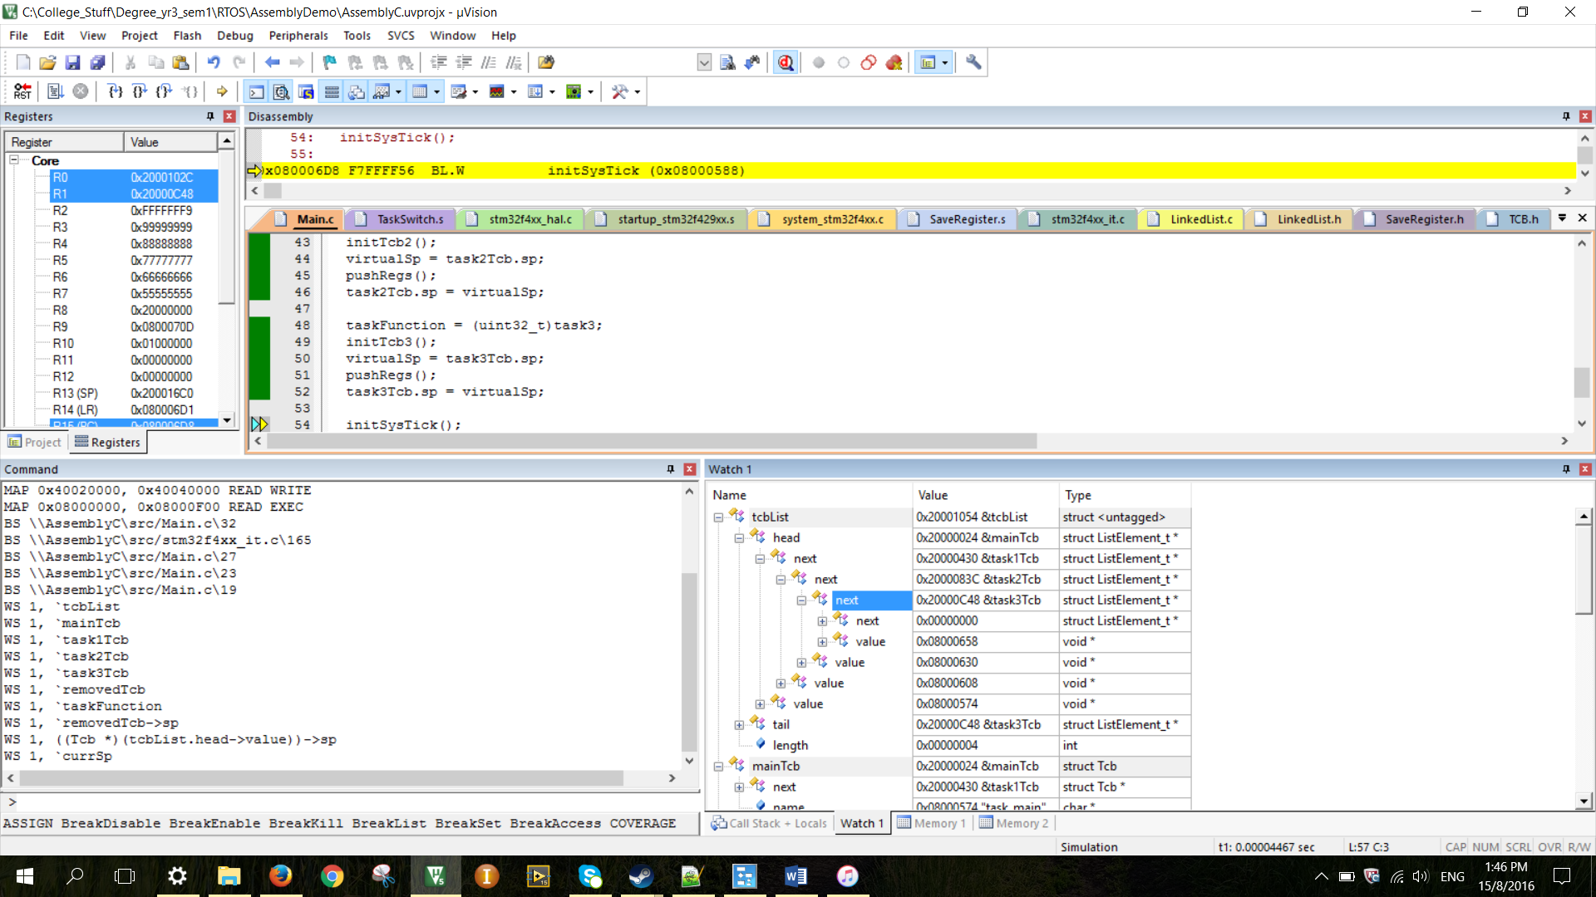

Figure 11 the initial resuslt for the linked list.

The result shown in figure 11 match the expectation shown from figure 5.

The reload register of the timer has set to be 0x00003E7F. The counter will start from the value of the reload register. When counter reach 0, the interrupt occur and the counter value reload to the value of the reload register.

Before interrupt, the program will run continuously at the while loop of the main. When interrupt occur, the program will go to the ISR shown in figure 8 and some registers will be pushed to the stack respect to the SP address. The register before and after pushing will be shown in figure below.

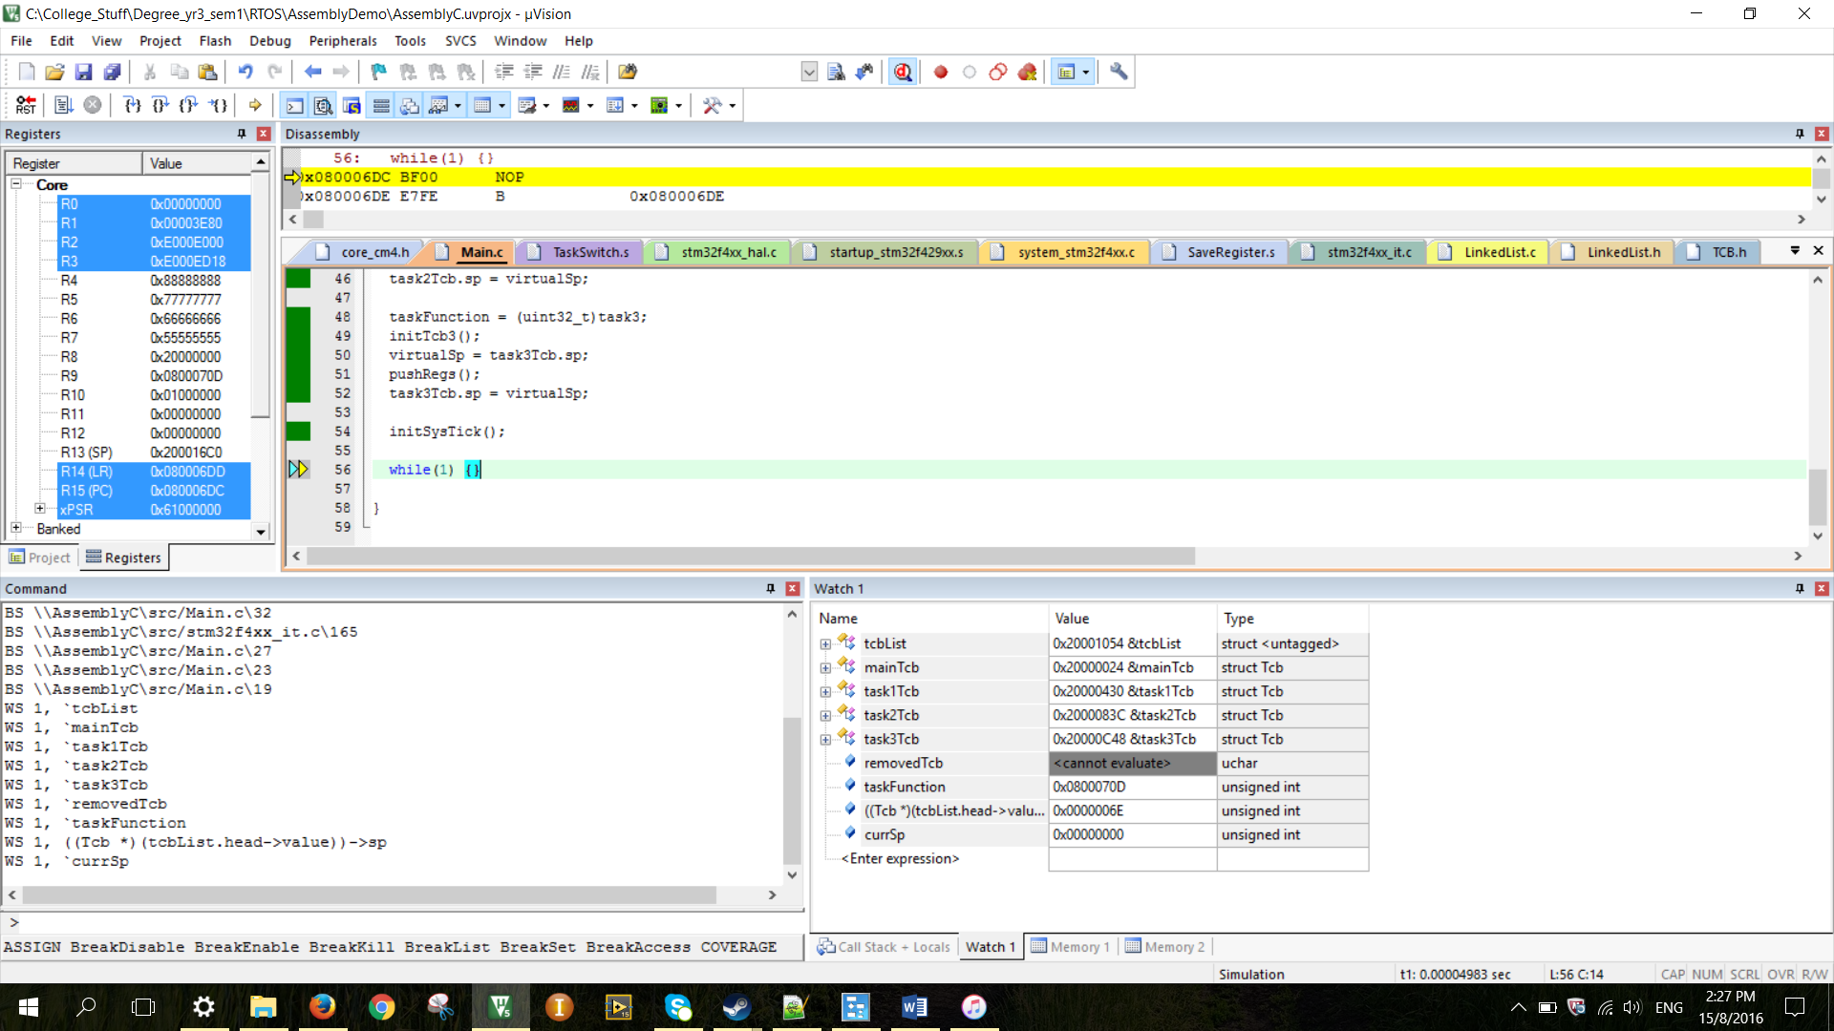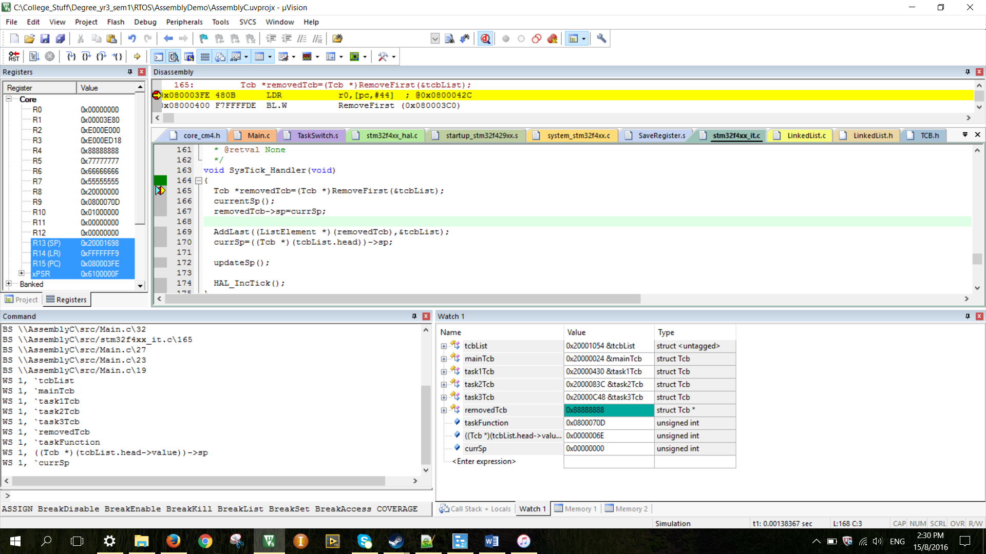

Figure 12 Register before and after push.

From the figure above, note that the SP value has been changed. Which means the register mentioned in previous section has been pushed into the stack. The value of the SP for the removed first element has been updated and placed at the tail of the linked list. The linked list is as shown below.

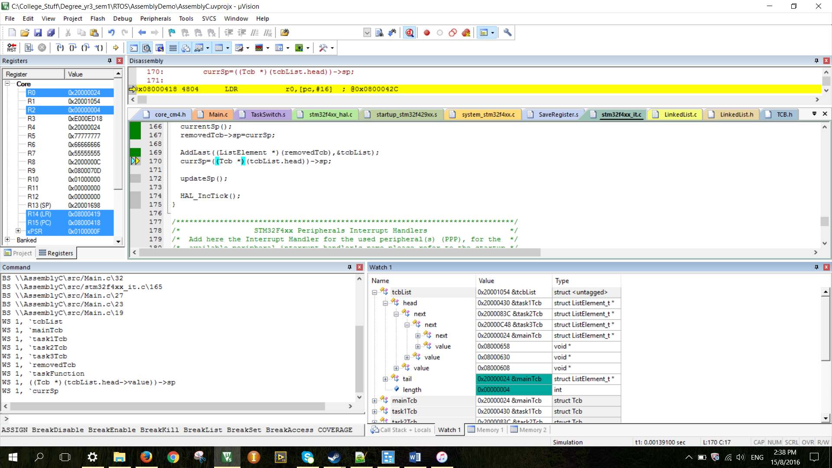

Figure 13 linked list after the element removed and thrown to the tail.

The actual SP value has been updated by the SP value of the first element of the linked list. Hence, the poping out of the registers are respecting to the task1Tcb. The register before and registers after poping out is as shown below.

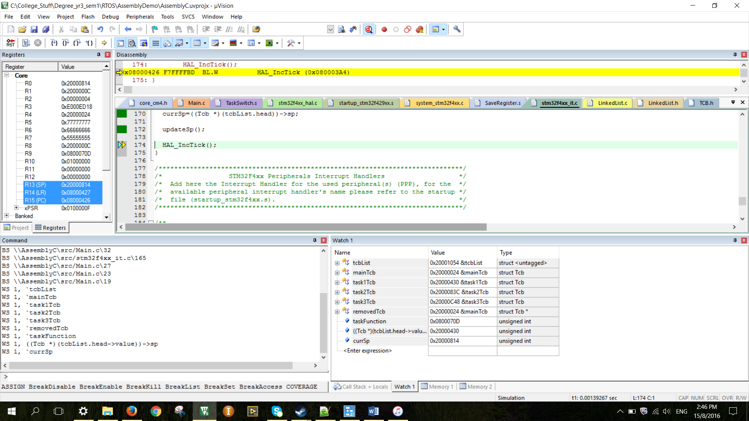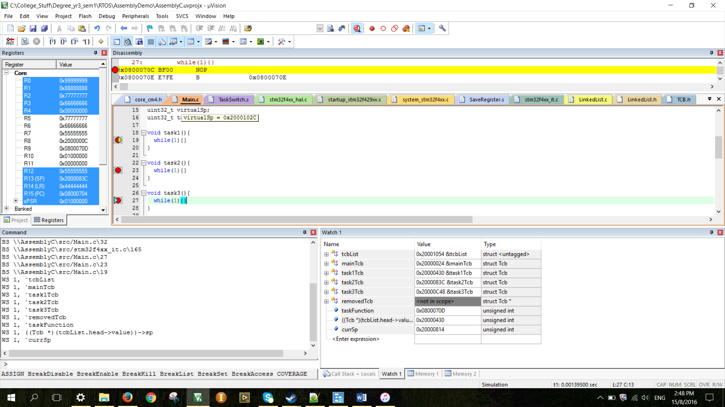

Figure 14 Register before and after pop.

From the figure above, the register has been poped out. Note that the PC value is the value r9 been push from the figure 6. That value is the address of the function task1 as shown in figure below.

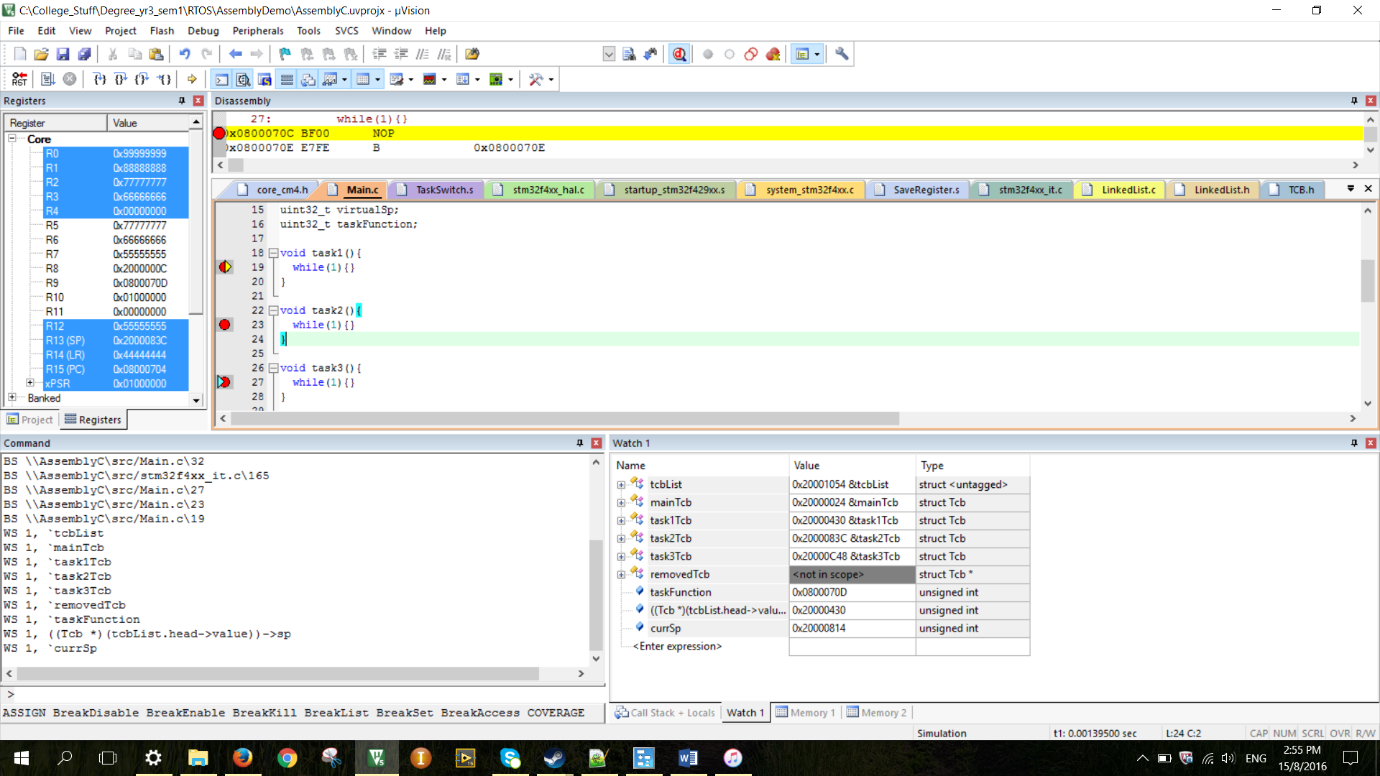

Figure 15 function task1.

The break point has been set at the task1( ). So after the program leaving the ISR, the program is now at the task1 rather than inside the main. Note that inside task1 ( ), there is a while loop. Again when the timer of the ISR expired, the program will got to the ISR and task switch again and result as below.

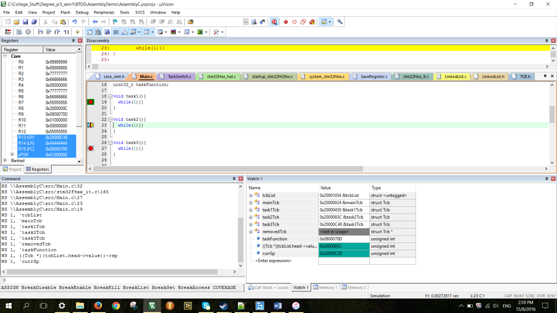 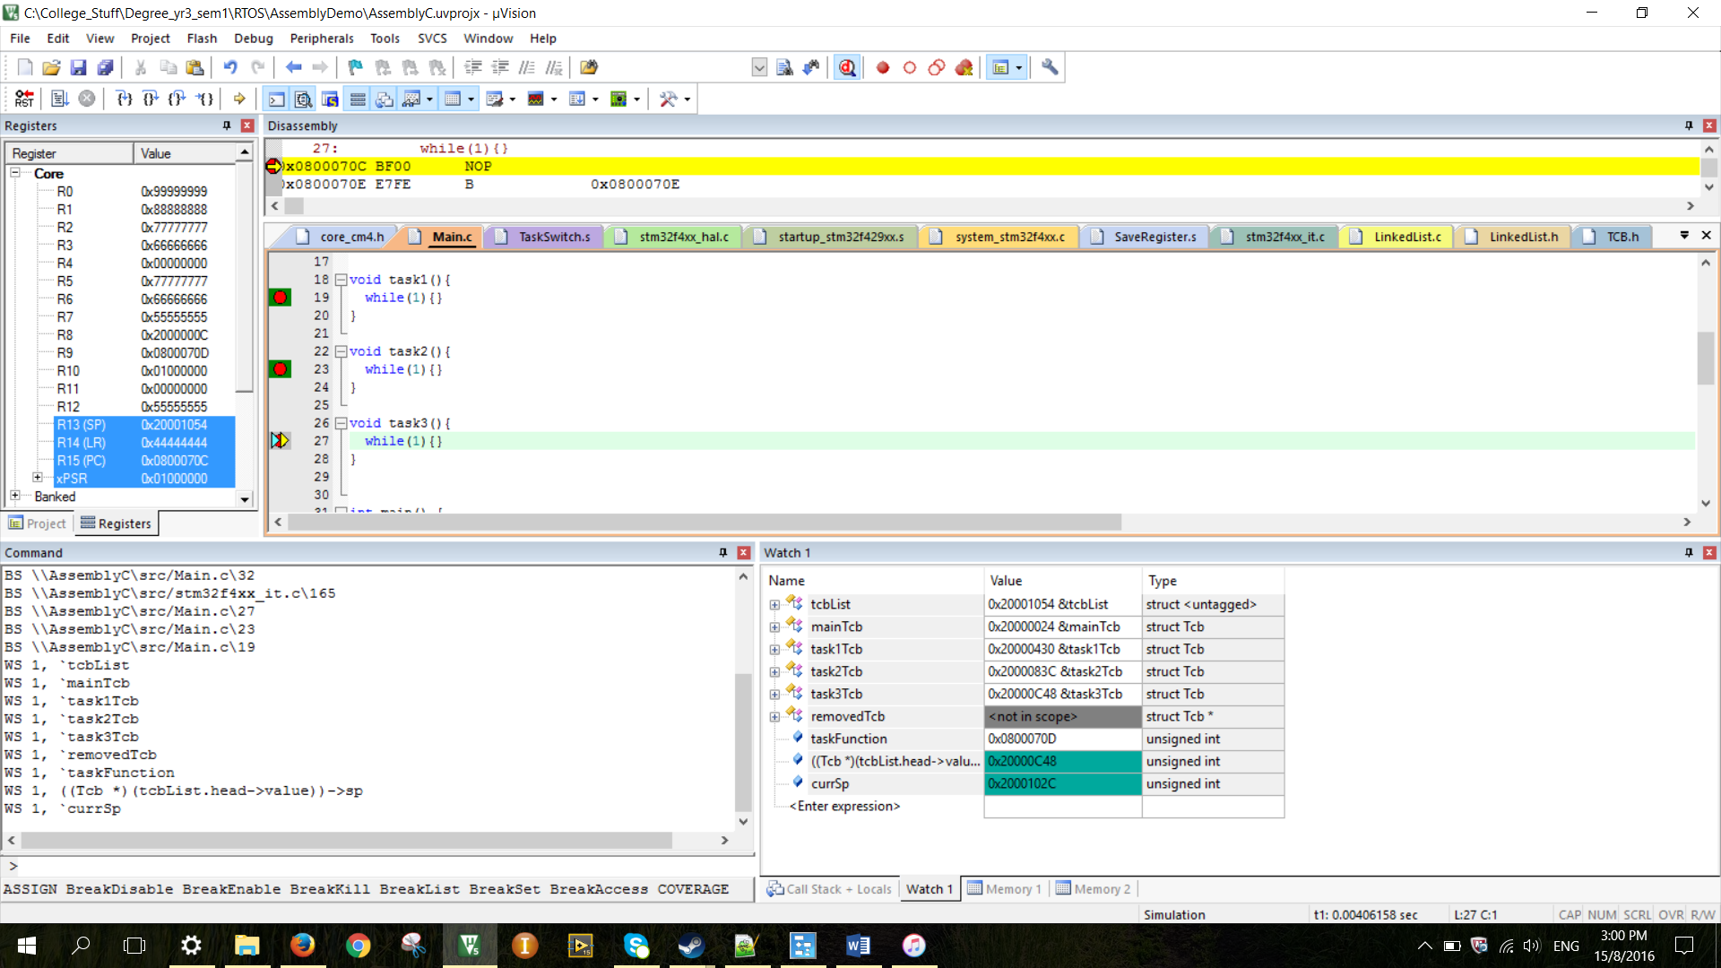

Figure 16 task switched.

The cycle will be repeated and so the task switching is successfully implemented.

# CHAPTER IV: CONCLUSION

The task switching has been successfully implemented in C and Assembly by using software $μVision$. The task are linked by a linked list and the process can be cyclic.